Colonial League All League Team
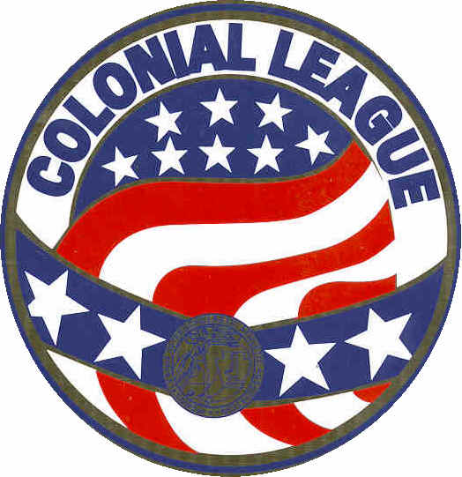

This Award is Given to

Of
__________High School
in recognition of having been selected as a Colonial League
Second Team _________ in __________
during the season of ________

________________ _________________ _________________
Athletic Director Coach Principal

